The Tragedy of Flights: A Comprehensive Analysis of Flight Crashes.

A Project Report

Submitted by

N. SELVA KUMAR

(Register No: 20201071522123)

S. SATHYA

(Register No: 20201071522122)

I. SUMITHRA

(Register No: 20201071522126)

P. SUNDARA GOMATHI

(Register No: 20201071522127)

**BACHELOR OF SCIENCE**

**IN**

**PHYSICS**



**DEPARTMENT OF PHYSICS**

**THE MADURAI DIRAVIUM THAYUMANAVAR HINDU COLLEGE**

**TIRUNELVELI – 627 010.**

|  |  |  |
| --- | --- | --- |
| SI.NO | CONTENTS | PAGE NO |
| 1. | INTRODUCTION:   * 1. Overview   A brief description about the project.   * 1. Purpose   The use of this project. What can be achieved using this. | 4 |
| 2. | PROBLEM DEFINITION AND DESIGN THINKING:  2.1 Empathy Map.  Paste the empathy map  screenshot. Identification & Brainstorming Map.  2.2 Paste the Identification & Brainstorming map screenshots. | 5 |
| 3. | RESULT  Final findings (output) of the project along with the  Screenshots. | 14 |
| 4. | ADVANTAGES AND DISADVANTAGES  List of Advantages and Disadvantages of the  Solution. | 15 |
| 5. | APPLICATIONS  The areas where this solution can be applied. |  |
| 6. | CONCLUSION  Conclusion summarizing the entire work and  Findings. | 16 |
| 7. | FUTURE SCOPE  Enhancement that can be made in the future. |  |

TABLE OF CONTENTS

|  |  |  |
| --- | --- | --- |
| 8. | APPENDIX |  |

INTRODUCTION

* 1. Overview

Despite the fact that many air passengers worry about them, plane crashes are in fact extremely rare. There are wide range of estimates given by different sources, but the odds of dying as a plane passenger are usually quoted as around 1 in 2,00,000.

This compares with odds of 1 in 4,000 for dying as a cyclist, and about in 1 in 100 in a car crash.

* 1. USES

Air crash analysis is used to collect the data of the air crashes which have been taken place all over the world during the past years. It also deals with the measures which have to be undertaken during the time of the flight crashes.

2. PROBLEM DEFENITION AND DESIGN THINKING

2.1 EMPATHY MAP:

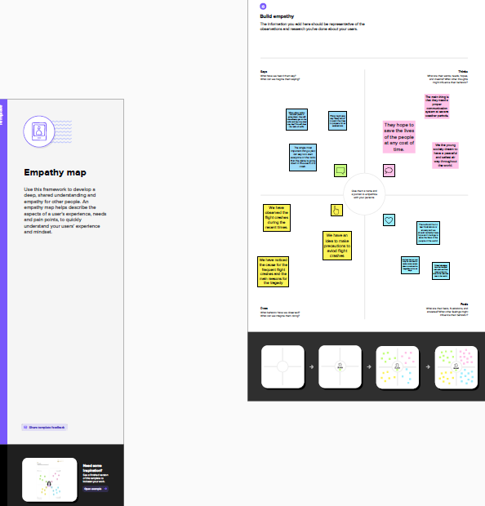

2.2 IDEATION & BRAINSTORMING MAP

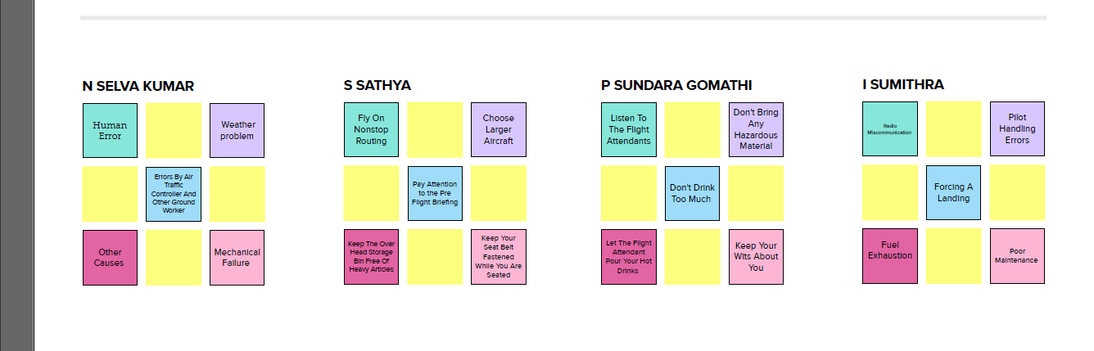

SCREENSHOTS OF DASHBOARD AND STORY:

DASHBOARD 1

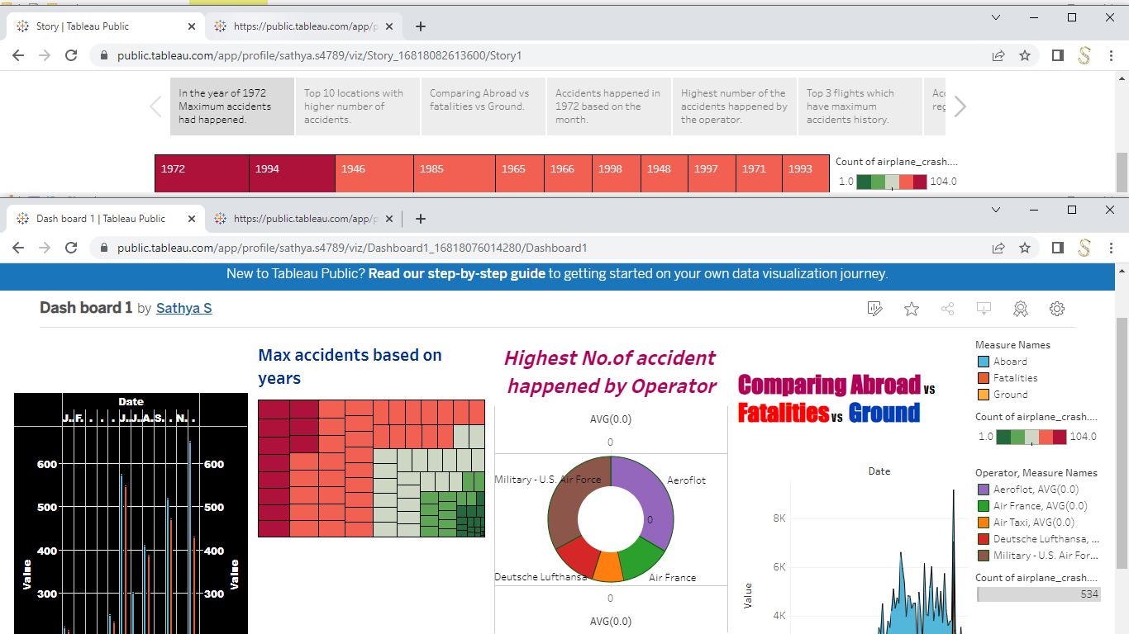

DASHBOARD 2

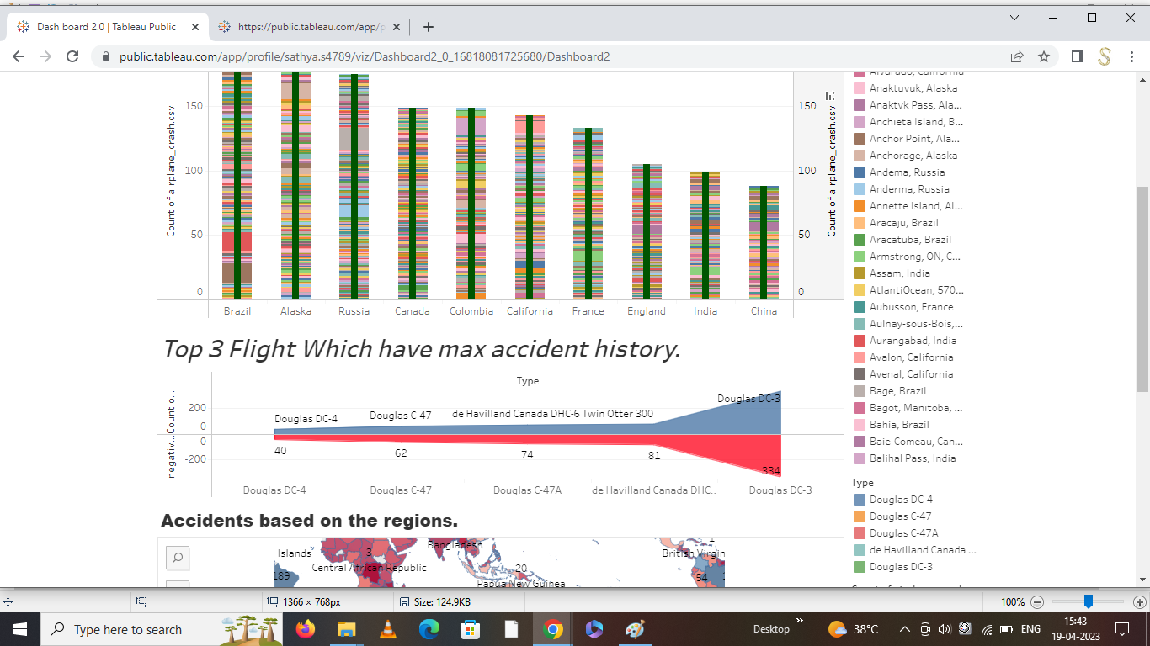

STORY

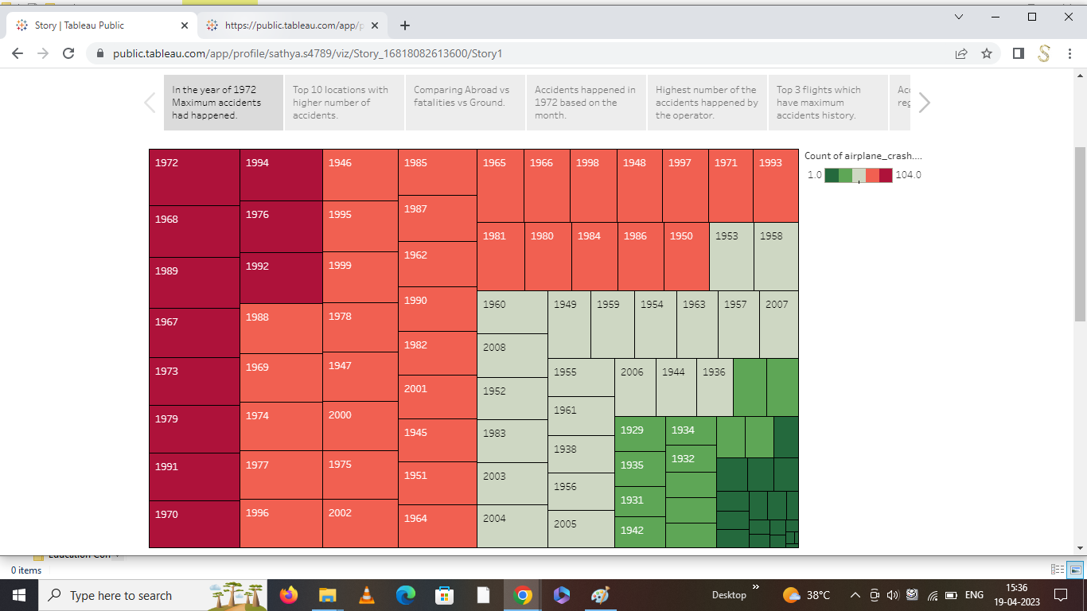

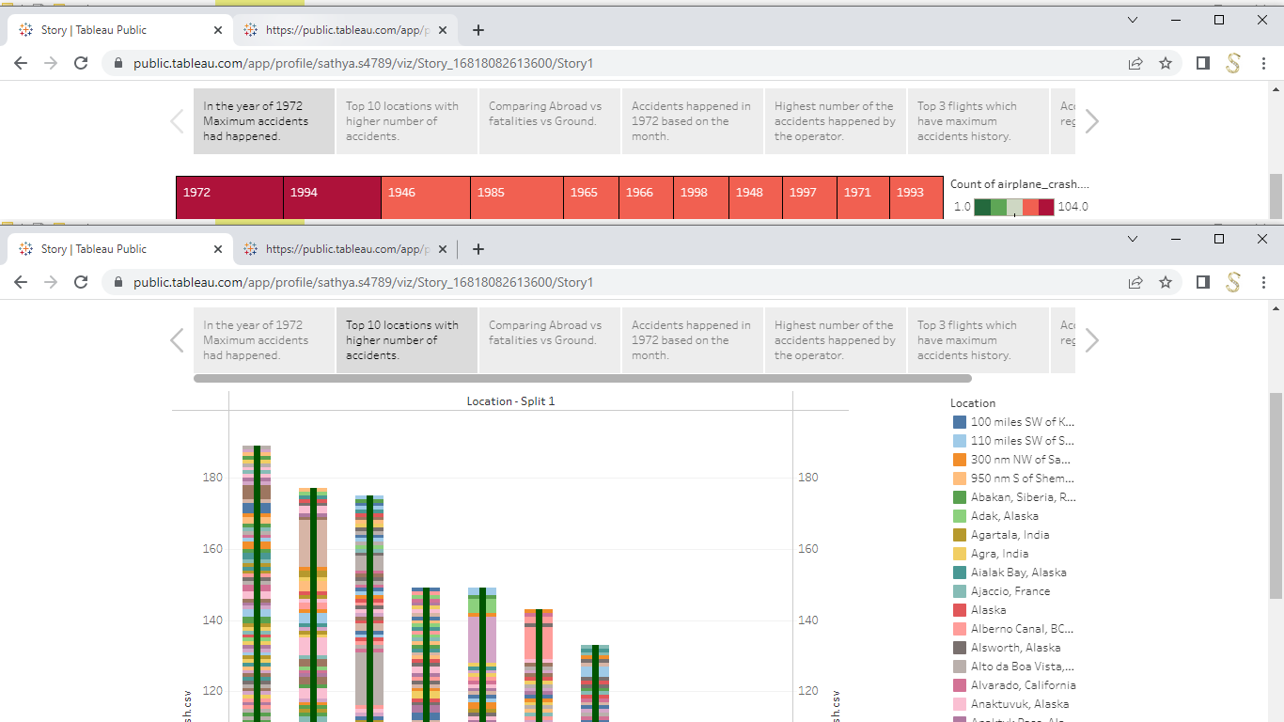

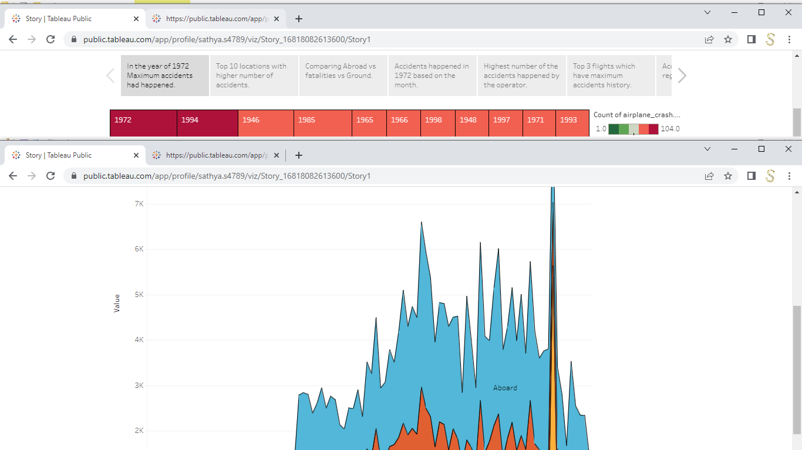

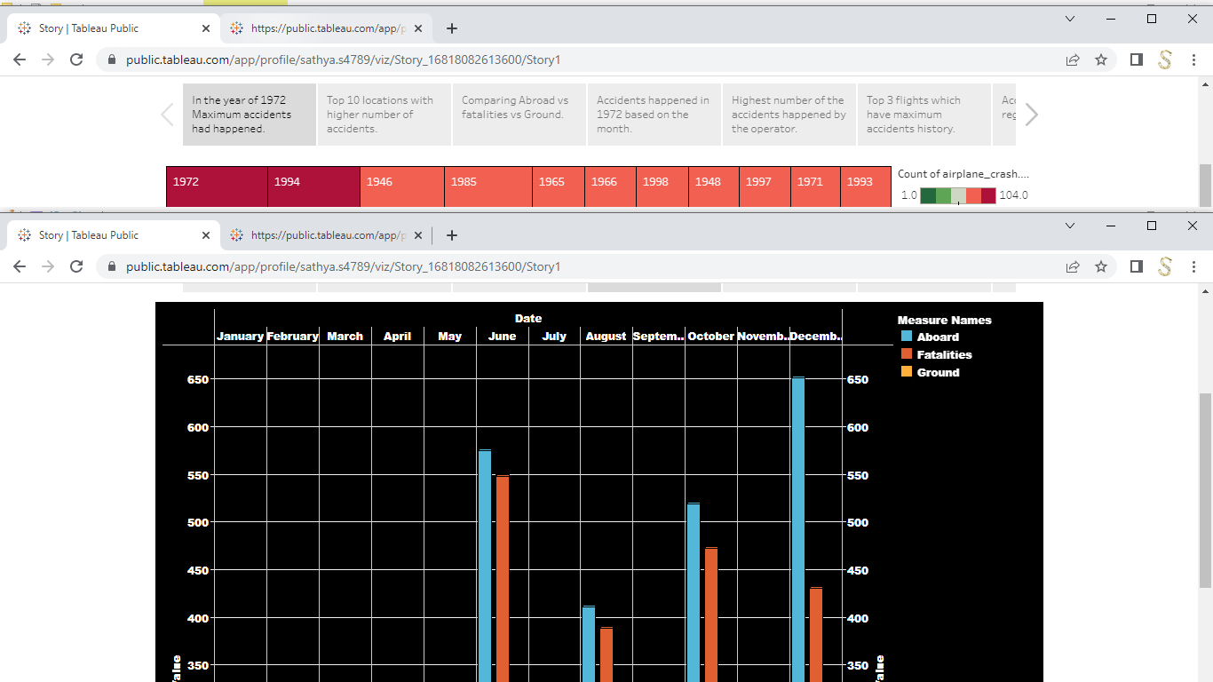

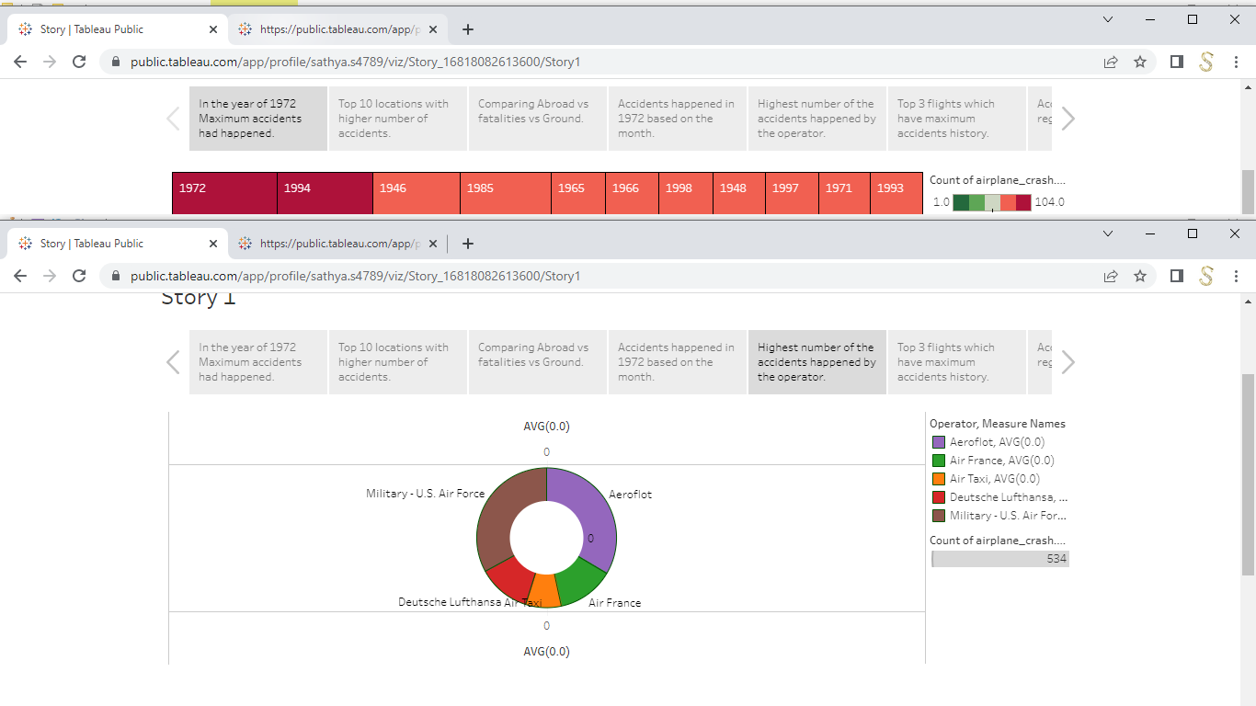

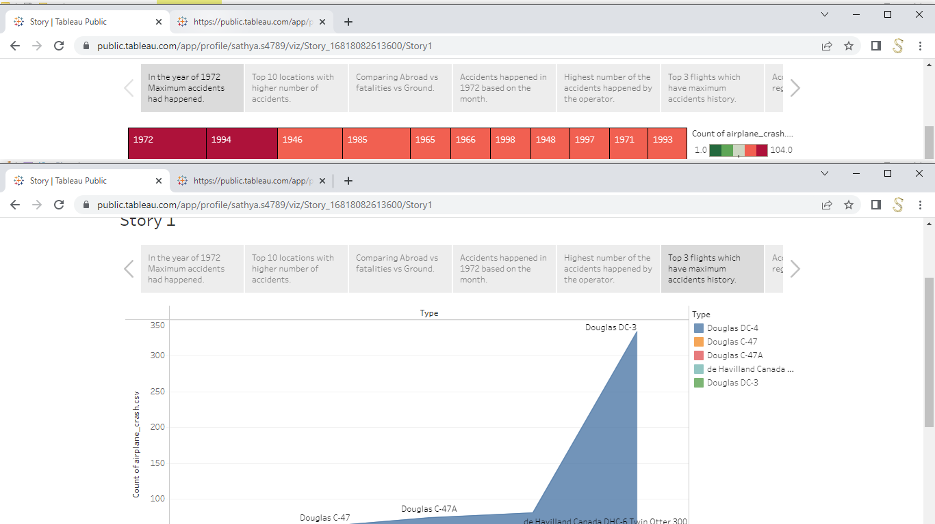

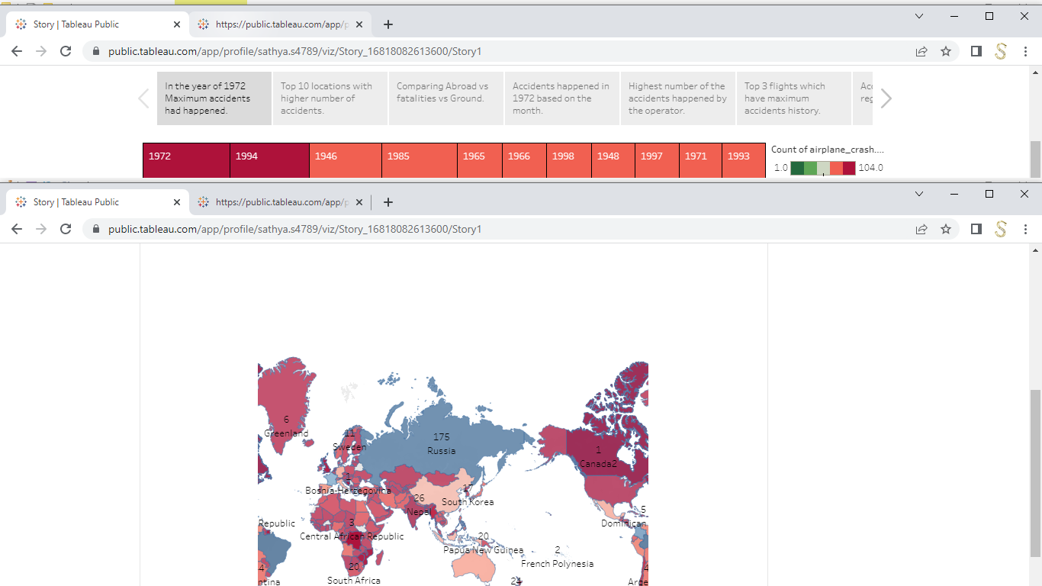

SCREEN SHOTS OF THE WEB INTEGRATION

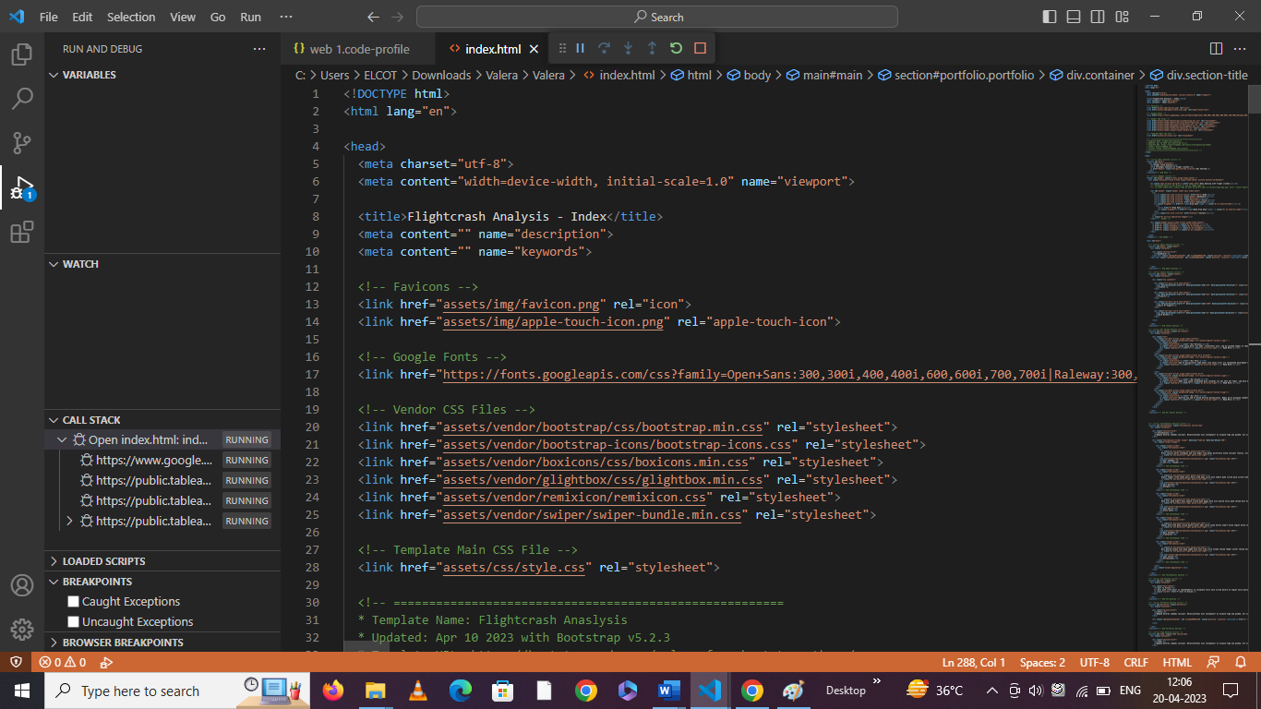



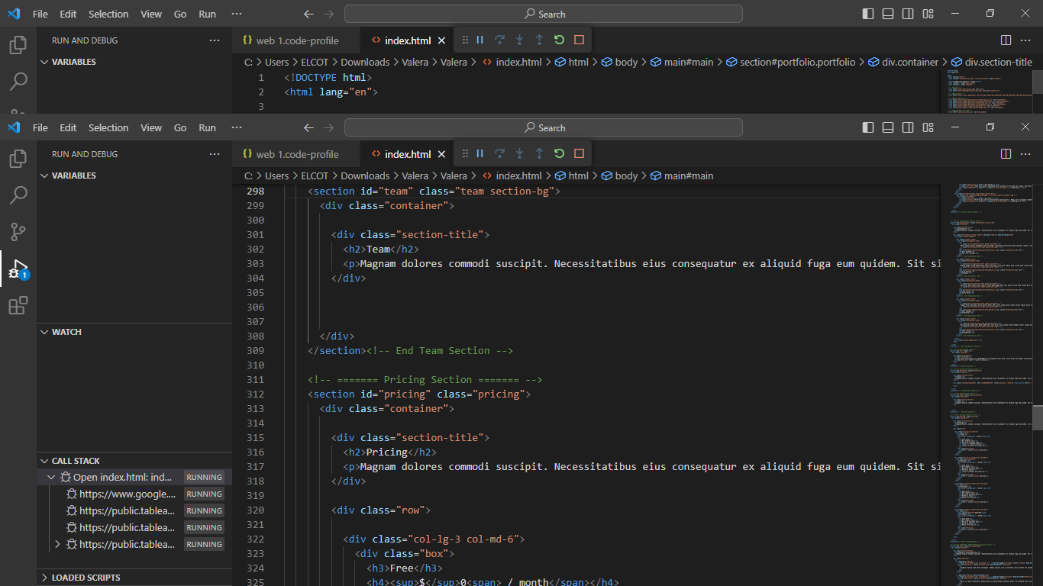

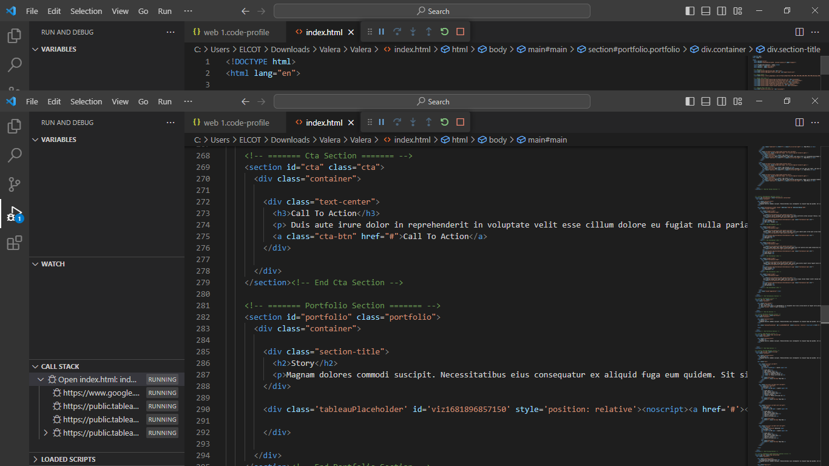

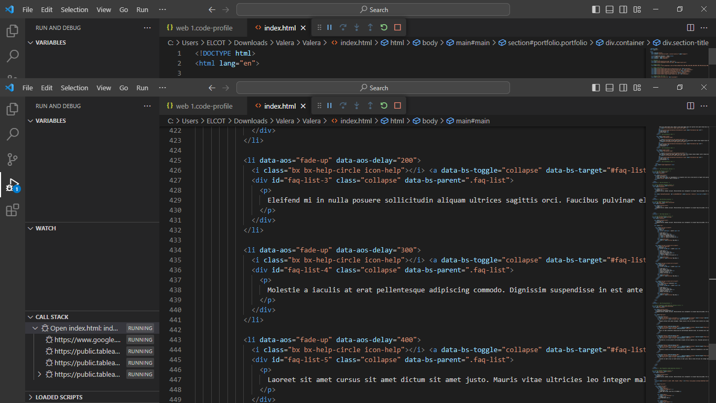

RESULT:

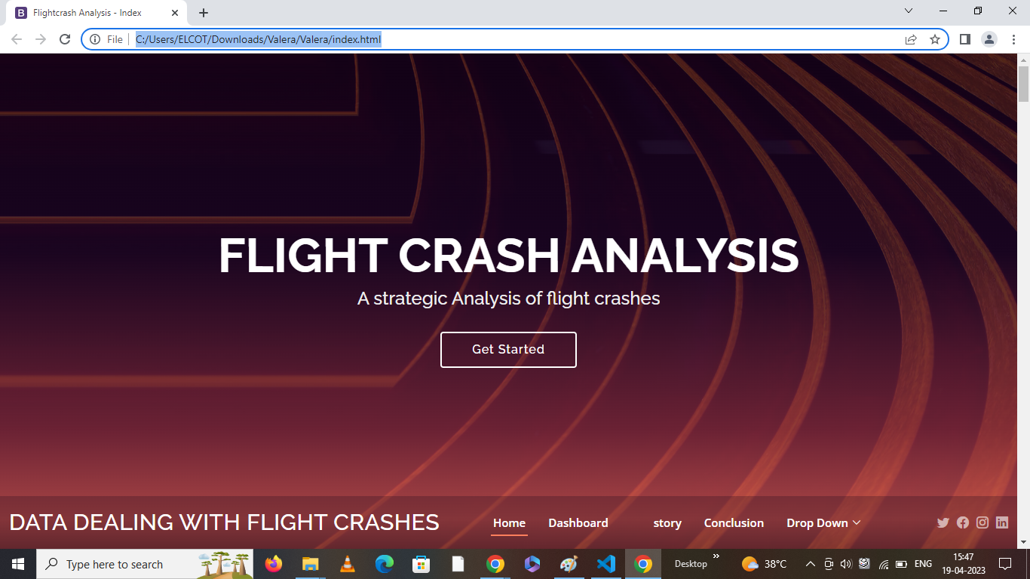

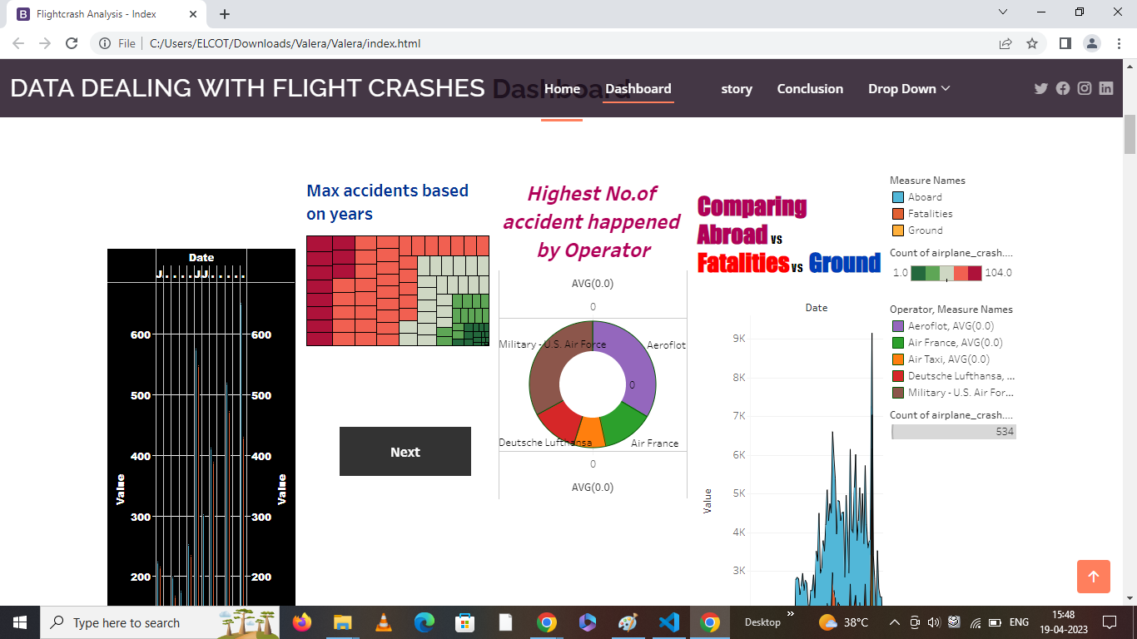

ADVANTAGES:

The project has the advantages of analysing the data of the flight crashes. So by using this we can study the flight crashes held on the past years. Using these data we can analyse the cause of the accident so by using the data we can avoid the future accidents and we can understand the cause of the accident and make some measures to avoid the accidents.

DISADVANTAGES:

Overall the project shows the damages which have affected the lives and the infrastructure of the economy.

CONCLUSION

The project deals about the flight crashes which have take place in the past few years and the measures which has to be taken during the critical situations. Finally the project is used to analyse the data about the flight crashes which have been held in the past years. Hereby the project has the details such as the year which has the most flight crashes and the top 10 locations which has been frequently by the flight crashes.